ABSTRACT

The rapid integration of technology into everyday accessories presents an innovative approach to enhancing personal safety while preserving the aesthetic appeal of traditional ornaments. This research paper explores the design and implementation of a "Smart Anklet" tailored for women's safety and convenience. Leveraging Internet of Things (IoT) technology, the smart anklet serves dual purpose of both a fashionable accessory and an advanced safety device.

By embedding discreet sensors and communication modules within the anklet, the device can detect and respond in a situation where the woman is in danger. In the event of an emergency, such as a distress situation or a perceived threat, the smart anklet automatically triggers an alert mechanism. This mechanism promptly sends distress signals to pre-designated family members and nearby law enforcement agencies, facilitating swift assistance and intervention.

The research methodology involves the development and prototyping of the smart anklet, utilizing IoT principles for seamless connectivity and efficient data transmission.

The aim of this research is to demonstrate the potential feasibility and efficacy of integrating smart technology into traditional jewellery to address contemporary safety concerns. The Smart Anklet not only enhances the wearer's sense of security but also empowers them with discreet and immediate access to assistance when needed. Moreover, the dual-purpose nature of the device promotes its acceptance and adoption among women, seamlessly blending functionality with fashion.

Overall, this research contributes to the emerging field of wearable technology by showcasing a novel application of IoT in enhancing personal safety. The Smart Anklet represents a promising avenue for future innovation in the intersection of fashion, technology, and safety, with potential implications for broader societal well-being and empowerment.

**Keywords: Women’s safety, IoT, Wearable device, Arduino, Smart Anklet**

**INTRODUCTION**

Women's safety is one of the primary concerns that continues to demand attention and action worldwide. In every corner of the globe, women face unique challenges and vulnerabilities on a regular basis. From the threat of harassment and violence in public places to domestic abuse behind closed doors, women face it all. In recent years, concrete efforts have been made to address these issues through legislation, advocacy, and the development of innovative technologies aimed at enhancing women's safety. Despite these efforts, much work remains to be done to create a world where women can live free from fear and violence. In every aspect of life, we have been using science and technology to solve our problems, so why not this? Our device ‘Smart Anklet’ demonstrates how wearable IOT devices can take us a step forward in making this world a safer place for women.

LITERATURE REVIEW:

**PROPOSED SYSTEM:**

The main goal of the paper is to improve women’s safety and security. We use multiple sensors and actuators for the project like pulse sensor, temperature sensor, vibration sensor, ESP32 cam and GPS modules.

Types of sensor used and their purpose:

1. Temperature sensor for measuring the body temperature of the victim
2. Pulse sensor for pulse waves or normal/abnormal heartbeat of the victim

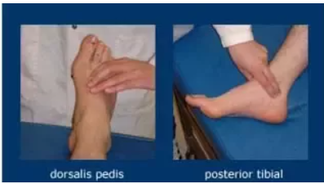

These are the two pulse points in our foot. The first one, **Dorsalis pedis** is away from the scope of the anklet. But, **posterior tibial** aligns with the exact position of where anklets are worn.

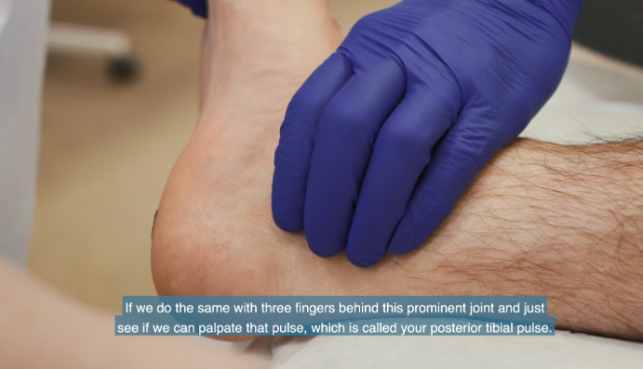

1. Vibration sensors are responsible for measuring the vibration acting on a body (if anytime the victim is getting forced and pulled by a culprit).

The data (Pulse, Temperature) gets updated whenever the concerned person opens the app. The location of the user is also updated using Google maps. The vibration sensor has some threshold value set up in it. If the vibration rate is abnormal, the family members get notification on the phone and by further navigating through blynk app, they can get all the necessary details required to save the victim. The BLYNK app is configured in the well-wisher’s device in such a way that the user’s information gets updated on their device. The advantage is all the sensors used here are very small in size and portable to handle in any condition. They are user-friendly and cost viable. By comparing to the literature survey taken, the user no need to press the button when she is in danger.

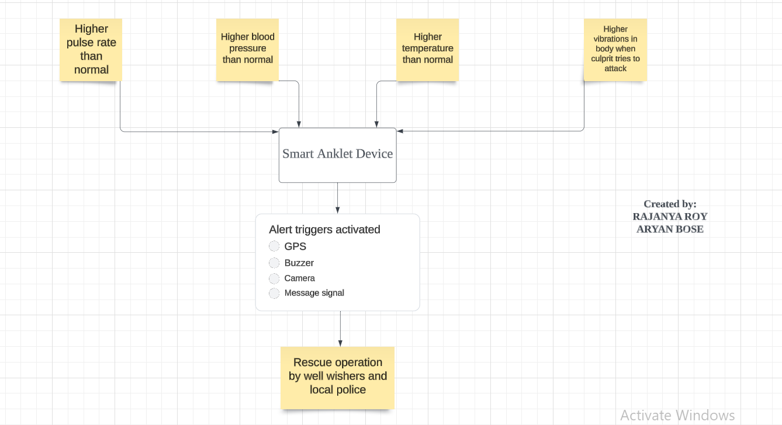

Flowchart of the proposed system using **Lucidchart**

**HARDWARE REQUIREMENTS:**

1. Arduino UNO:

The Arduino Uno microcontroller board utilizes a Microchip ATmega328P microprocessor, which occupies a compact 74cc space. In addition to offering 14 digital input/output (I/O) pins, six of which are capable of generating Pulse Width Modulation (PWM) signals, the board also features six analog input/output pins. These pins can be programmed using a type B USB cable in conjunction with the Arduino Integrated Development Environment (IDE).

1. Esp 32:

The ESP32 chipset is a single-chip solution combining 2.4 GHz wireless and Bluetooth functionalities, crafted using TSMC's 40 nm ultralow power technology. Requiring fewer than 10 external components, it stands out as a highly integrated solution for Wi-Fi and Bluetooth applications. This chipset boasts an impressive array of integrated components, including an antenna switch, RF balun, power amplifier, low noise receive amplifier, filters, and power management modules, along with a built-in power management system. Its versatility makes it suitable for a wide range of IoT applications, from mobile devices and wearable electronics to smartphones.

1. Esp32 Cam:

A video camera and socket for a microSD card are built into the ESP32-CAM, which is a full-featured microcontroller. With this camera, you can create IoT devices that can perform image tracking and recognition. It’s inexpensive and easy to use. There are a variety of IoT applications that can be implemented on the ESP32-CAM.

1. LCD 16x2:

16×2 LCD is one kind of electronic device used to display messages and information. The term LCD full form is Liquid Crystal display. The display is named 16×2 LCD because it has sixteen Columns and 2 Rows. it is able to be displayed (16×2=32) 32 characters in general and every person could be made of five×8 Pixel Dots.

1. FT232RL:

Connecting serial devices with RS232 to devices supporting USB is a simple process using the USB-to-RS232 converter cables. An FTDI cable includes an FTDI FT232R chip mounted on the internal electronic circuit. Using FTDI chips, you can convert serial to USB data and vice versa. With this cable, you can connect a TTL serial interface to a USB in a simple and cheap way. It is necessary to download a device driver to use this FTDI cable.

1. FT232RL FTDP Temperature Sensor:

A temperature sensor is a device which measures an object’s temperature. This could be the temperature of the air, a liquid, or a solid.

1. Vibration Sensor:

Temperature Sensor Fig. 5. LCD 16x2 In piezoelectric accelerometers, vibrations are detected through their movement. Vibration can be measured at normal speeds or accelerations as well as fluctuations. Piezoelectric effects are utilized to measure changes in acceleration, pressure, temperature, force, otherwise, strain by converting a voltage into an electrical charge.

1. Pulse Sensor:

Pulse Sensor is an Arduino heartcharge sensor that is welldesigned and easy to use. With a few jumper cables,the sensor clamps onto a fingertip or earlobe and connects directly to Arduino. It’s also a free monitoring app that displays your pulse in real time.

1. GPS:

The global positioning system (GPS) is a comprehensive navigation system based on satellites that uses at least 24 satellites. With no subscription fees or setup charges, GPS operates in every weather condition, anywhere within the international, 24 hours a day, seven days a week. It gets data from satellites in the form of an NMEA string, which includes latitude, longitude, altitude, UTC time, and so on. This text wishes to be parsed in order to get the records we need.

**SOFTWARE REQUIREMENTS**:

1. Arduino IDE: Within the Arduino IDE, users access a text editor tailored for coding, complemented by a message space and text console that relay vital information and errors. Basic functions are readily accessible via intuitive buttons, while customization options are available through menus. Integration of packages and communication with them is seamlessly facilitated through the Arduino hardware. The console serves as a hub for textual content, furnishing error messages and statistics crucial for debugging and code execution oversight.
2. Blynk App: With Blynk App for iOS and Android, you can create mobile apps that work with the hardware of your choice. It manages all the connection routines, as well as data exchange, between your hardware, Blynk Cloud, and your app project. In the Blynk app, every time a button is pressed, the message is sent to the Blynk Cloud, where it finds its way to your hardware. Similarly, everything happens in a blink of an eye in the opposite direction as well.

References:

1. Priya Biradar, Priyanka Kolsure, Sujata Khodaskar , Kishor B. Bhangale, ”IoT Based Smart Bracelet for Women Security” International Jour- nal for Research in Applied Science and Engineering Technology (IJRASET) ISSN No: 2321- 9653, Vol 8, Issue No. 11, February 2020
2. V.Ebenezer, Uvaana Falicica J, M. Roshni Thanka, Rithika Baskaran, Agatha Celesty, Sejal R Eden, IOT Based Wrist Band for Women Safety, Journal of Artificial Intelligence and Technology (2023)